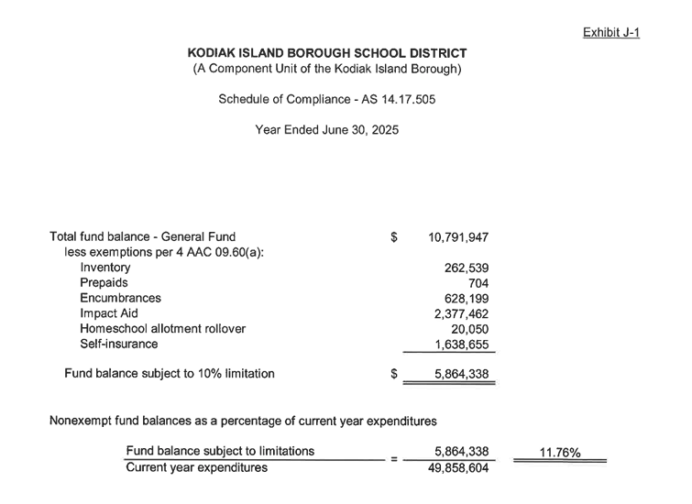
$5,864.338
Committed from Fund Balance for FY26 Budget:
- June 16 Adopted FY 26 Budget us of $4,972,353 of fund balance (at $340 BSA)
- September 15 Approved Transfer of $262,536 to Child Nutrition Fund

$5,234,889 Use of Fund Balance for FY26

$5,864.338 FY 26 Fund Balance
- $5,234,889 Use of Fund Balance for FY26

$629,449 Remaining Fund Balance projected for FY27 at $340 BSA

+ $521,851 anticipated from BSA $700 (Budget Revisions on 11/17).

$1,151,300 Projected FY27 Fund Balance (11/17)

+ 1,130,512 HH and 3 additional INF (Winter Revision 1/26/26)
-$500,000 Winter Revisions Expenditures (Winter Revisions 1/26/26)

$1,781,812 Projected Fund Balance for FY27 on July 1, 2026

Updated 1/25/26
Estimated FY27 Fund Balance

