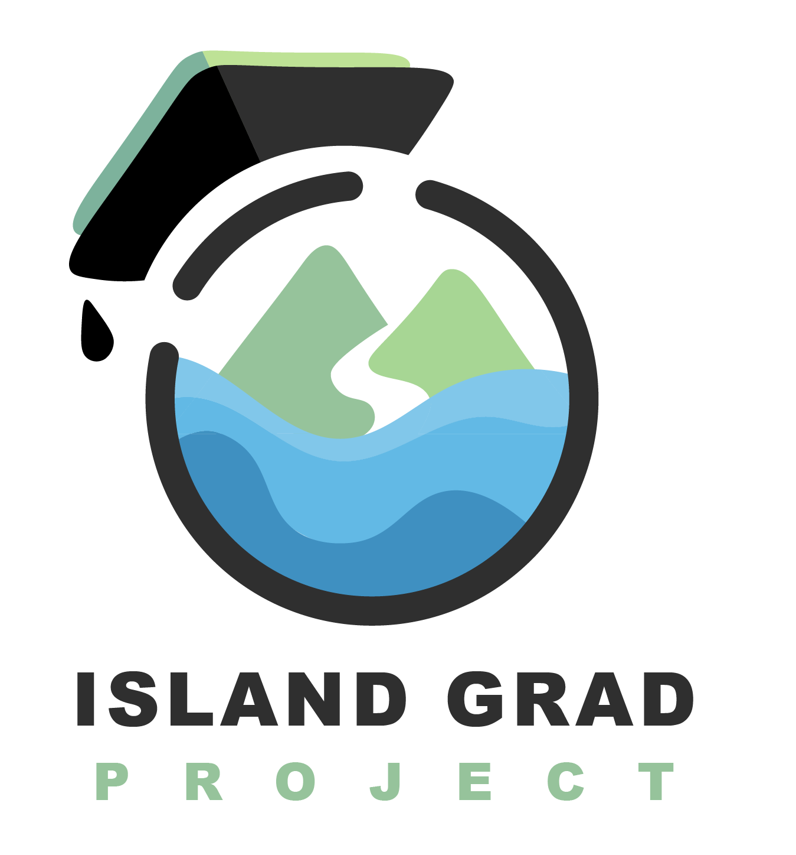

SCHOLARSHIP APPLICATION
2024-2025

Island GRAD Project (IGP), a 501(c)(3) nonprofit college and career access organization, has established a scholarship fund to support Kodiak Island students in their pursuit of postsecondary education. This fund is created through community donations and scholarship sponsors. Our mission is to increase postsecondary attainment in the Kodiak region through resource connection, process navigation, community partnerships, and student support.

IGP is committed to supporting all pathways to meaningful careers that pay a living wage, including both college and workforce training, industry certifications, apprenticeships, and more. We encourage students to complete both academic and technical skill-based training.

Scholarship Timeline:

Applications Due: April 15, 2024
Recipients Notified: May 15, 2024
Funds Disbursed: June 30, 2024 (no later than)

The number of scholarship recipients will be determined by the funds available to award each year.

Scholarship Preference:

All IGP Scholarships have a preference for applicants who are attending college in Alaska, or who can explain why they chose to attend college out of state and how they intend to contribute to Kodiak and/or Alaska after graduation.

Submitting Scholarship:
The completed application and supporting information can be returned to the Kodiak College Financial Aid Office no later than April 15, 2024 or email PDF documents to Nancy Castro at ncastro2@alaska.edu.

IGP Academic Persistence Award ($1,000)

- Applicant Requirements:
  - Applicant must be a graduate of a Kodiak Island high school or has earned their GED while living in Kodiak (previous homeschool students from Kodiak are also eligible).
  - Applicant must have completed at least two consecutive semesters of college by the end of the 2023/2024 Academic Year (full-time or part-time)
  - Applicant must possess a cumulative college-level GPA of 2.5 or higher.

- Application Requirements:
  - Completed application
  - A copy of current unofficial college transcript (if awarded a scholarship, an updated transcript must be submitted prior to disbursement of funds).
  - 1-3 current, dated letters of recommendation. One letter must be from a college faculty or staff member.

IGP CTE-Workforce Training Award ($1,000)

- Applicant Requirements:
  - Applicant must be a graduate of a Kodiak Island high school or earned their GED while living in Kodiak (previous homeschool students from Kodiak are also eligible).
  - Applicant must be pursuing a non-college CTE or workforce training program (AVTEC, apprenticeship program, a short-term program leading to industry-recognized certifications or credentials, etc.).
  - Applicant must possess or be eligible to obtain a valid Alaska driver’s license.

- Application Requirements:
  - Completed application
  - A current resume of employment and/or internship history
  - 1-3 current, dated letters of recommendation. One letter must be from a current or former supervisor (employment, pre-apprenticeship, internship, etc.).

Please see applications for both categories attached. Questions can be directed to ncastro2@alaska.edu or (907) 486-1214

Good luck and we look forward to reviewing your applications!

The IGP Team

ACADEMIC PERSISTENCE AWARD APPLICATION

Applicant Information
First Name: ___________________________________ MI: _______
Last Name: ___________________________________
Birthdate: ____/____/______ HS/GED Graduation Date: __________ / ________
Month Day Year Month Year

Are you a 1st Generation College Student*? Yes: _______ No: ________
*Answer yes if neither of your parents have earned a bachelors degree. This information is collected for statistical purposes only, it is not a scholarship preference.

Contact Information

Phone: __________________________ Email: __________________________
Alternate Phone: ________________________
Permanent Mailing Address
Street/PO Box: _________________________________ City:____________________ State: ______________ Zip: _______________
Residency
Are you an Alaska Resident*? Yes: ______ No: ________
*Answer yes if you are have not claimed residency in another state and/or are eligible for the PFD.

Are you a Kodiak Island Borough Resident*? Yes: ______ No: _________
*Answer yes if you are only temporarily living off island to attend school or training.

School Information

Name of College Attended in 2023 / 2024: ____________________________________
Degree: ____________________________ Major: __________________________
Does this school use a semester or quarter system? Sem: _________ Qtr: ________
Credits Completed & Currently Enrolled: _____________
Name of College for 2024/2025: ___________________________________________
Degree: ____________________________ Major: __________________________
Does this school use a semester or quarter system? Sem: _________ Qtr: ________
Planned Enrollment: Part time: ___________ Full time: ___________
Are you enrolled in Fall 2025 classes yet? Yes: ________ No: _________
Do you plan to graduate in 2024/2025? Yes: ________ No: _________

If you are not attending college in Alaska, please tell us your reason for going out of state and how you intend to give back to the Kodiak region or Alaska after college graduation?

__________________________________________________________________________________________________________________________________________________________________________________________________________________________________________________________________________________________________________________________________________________________________________________________________________________________________________________________________________________________________________

Activities

Please list all sports, extracurricular activities, community service, hobbies, and interests that you have meaningfully participated in during your youth and/or at college?

____________________________________________________________________________________________________________________________________________________________________________________________________________________________________________________________________________________________________________________________________________________________________________________________________________________________________

Are you a current or former Kodiak Hockey League player (this is a requirement for one of our scholarship sponsors)?
Yes: _______ No: ______
Essay Questions

On a separate piece of paper, please respond to the following questions in 250 words or less per question.

- Tell us about your academic, career, and personal goals. Where do you see yourself 5-10 years after you have completed your education?

- Please share any obstacles you have faced that impacted your education and/or your transition from high school to college. What strategies did you use to overcome them?

- Pick ONE of your activities listed in the ‘Activities’ section of this application. Tell us how that activity impacted your life and how your participation in that activity impacted that organization or effort (Example: Did you make a difference or play a leadership role? Did the experience change your perspective or help you grow?)

- GRAD in Island GRAD Project stands for GRIT, RESILIENCE, ATTITUDE, and DREAMS. Tell us what these words mean to you and why you should be selected as an IGP scholarship recipient?

- Please tell us anything else you would like us to know about you. This can include any special circumstances or additional information about that you were not able to include in your previous answers.

The completed application and supporting information can be returned to the Kodiak College Financial Aid Office no later than April 15, 2024 or email PDF documents to Nancy Castro at ncastro2@alaska.edu

CTE-WORKFORCE TRAINING AWARD APPLICATION

Applicant Information
First Name: ___________________________________ MI: _______
Last Name: ___________________________________
Birthdate: ____/____/______ HS/GED Graduation Date: __________ / ________
Month Day Year Month Year

Contact Information

Phone: __________________________ Email: __________________________
Alternate Phone: ________________________
Permanent Mailing Address
Street/PO Box: _________________________________ City:____________________ State: ______________ Zip: _______________
Residency
Are you an Alaska Resident*? Yes: ______ No: ________
*Answer yes if you are have not claimed residency in another state and/or are eligible for the PFD.

Are you a Kodiak Island Borough Resident*? Yes: ______ No: _________
*Answer yes if you are only temporarily living off island to attend school or training.

School Information

Name of School or Training Program: _______________________________________
Location of School or Training Program: _____________________________________
Length of Program: ____________ Attendance: Part time: ______ Full time: ______
Are you accepted to the school or program? Yes: ________ No: _________
Credential(s) Awarded at Completion: _______________________________________
____________________________________________________________________
If you are not attending training in Alaska, please tell us your reason for going out of state and how you intend to give back to the Kodiak region or Alaska after the completion of your training program?

____________________________________________________________________________________________________________________________________________________________________________________________________________________________________________________________________________________________________________

Activities

Please list your hobbies, interests, and any community volunteering activities.

_________________________________________________________________________________________________________________________________________________________________________________________________________________________________

Are you a current or former Kodiak Hockey League player (this is a requirement for one of our scholarship sponsors)?
Yes: _______ No: ____________
Essay Questions

On a separate piece of paper, please respond to the following questions in 250 words or less per question.

- Tell us about your career and personal goals and how this training will help you achieve them.

- Please tell us anything else you would like us to know about you. This can include any special circumstance or additional information about that you were not able to include in your previous answer.

The completed application and supporting information can be returned to the Kodiak College Financial Aid Office no later than April 15, 2024 or email PDF documents to Nancy Castro at ncastro2@alaska.edu.

